Assignment - Data Analyst

Submitted by: Pooja Kumari Sureka

1. How are the efficiency numbers looking like? Can you share your views?

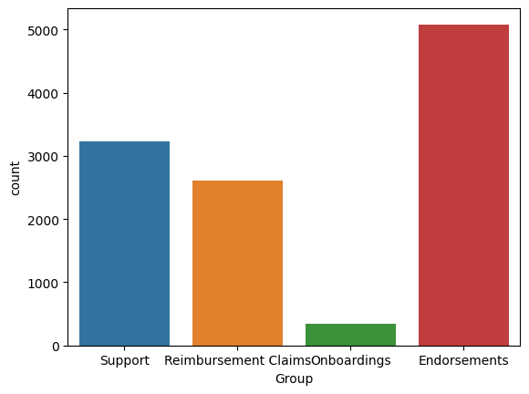

The "Endorsement" group solves maximum problems and the least is solved by the "Onboardings" team

1. Which groups are quick, slow etc. Create a table + relevant charts.

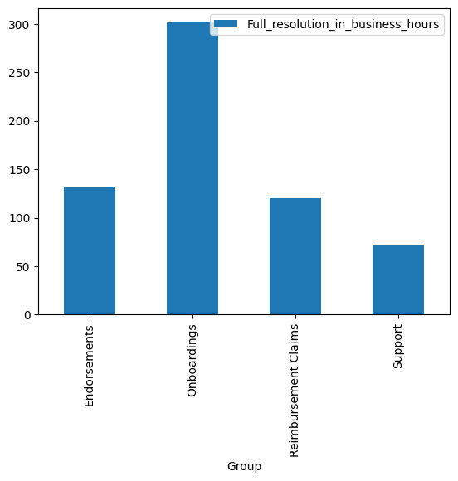

The "Support" group is quick in terms of average time taken to solve all problems is 72 hours whereas

The "Onboardings" group is slow in terms of average time taken to solve all the problems is 301 hours

|  |  |
| --- | --- |
| Groups | Average time required to solve an issue |
| Endorsements | 132 |
| Onboardings | 301 |
| Reimbursement Claims | 120 |
| Support | 72 |

c. What type of tickets are taking the most time to resolve? Create a table + relevant charts.

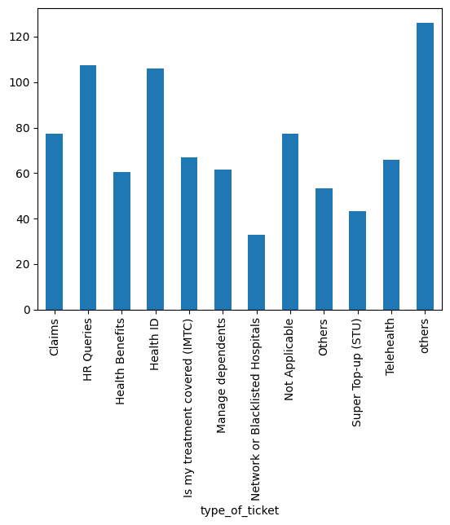

|  |  |
| --- | --- |
| type_of_ticket | Time in hours |
| Claims | 77 |
| HR Queries | 107 |
| Health Benefits | 60 |
| Health ID | 105 |
| Is my treatment covered (IMTC) | 66 |
| Manage dependents | 61 |
| Network or Blacklisted Hospitals | 32 |
| Not Applicable | 77 |
| Others | 53 |
| Super Top up (STU) | 43 |
| Telehealth | 65 |
| others | 126 |

"HR Queries", "Health ID", and "Claims" these tickets are taking more time to resolve a problem

d. Create the different type of data types we can infer from this data.

* **The "Endorsements" group has solved maximum number** of problems

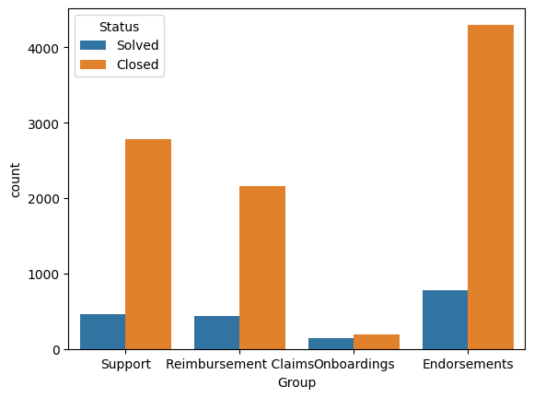

* All the problem solved via mail by these different groups has been categorized at a low "priority" level

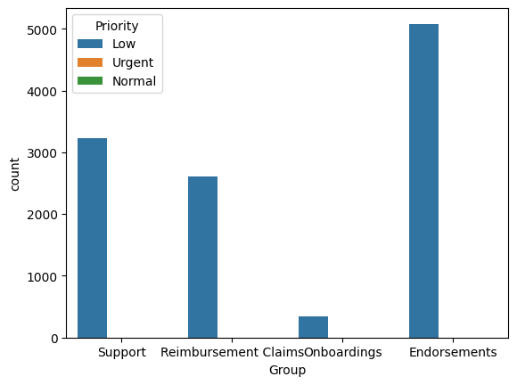

* "Endorsements" group is doing a great job as they are keeping the issue on hold for a minimum amount of time and solving then as soon as possible

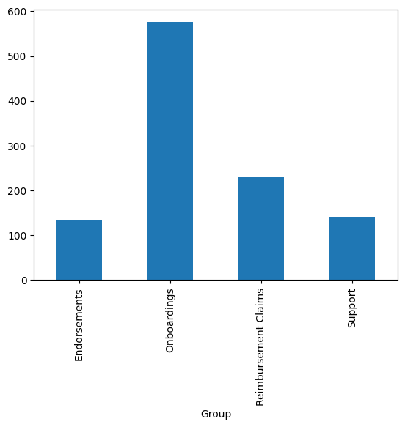

* “Waiting time” for a customer is minimum for Network or Blacklisted Hospitals and maximum for the health ID department

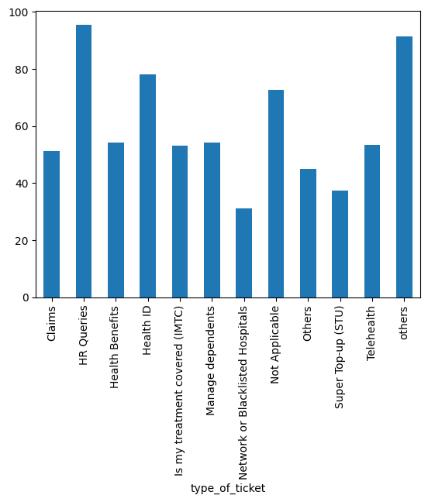

* Waiting time” for the customer is minimum for the support team and maximum for the Reimbursement Claims group.

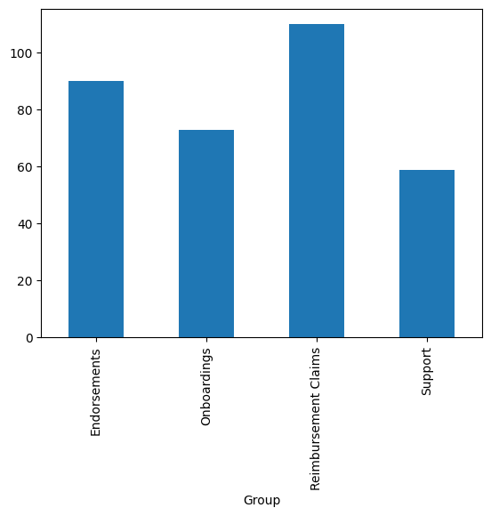

* "HR Queries" group is doing a great job as they are keeping the issue on hold for the minimum amount of time and solving then as soon as possible

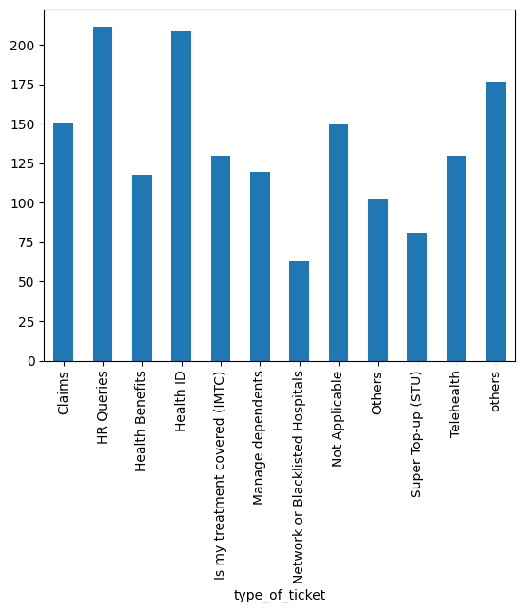

* For more detailed EDA analysis visit the link below: